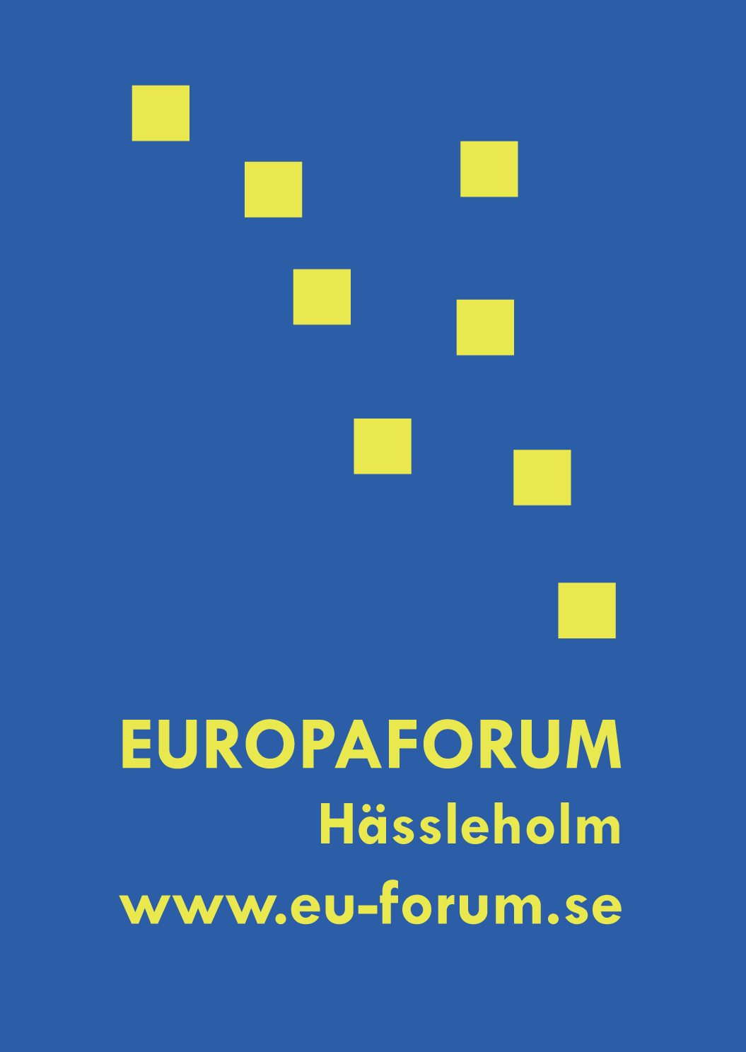

Information to participants

For general questions:

Please contact Therese Almqvist, EU-coordinator:
Telephone and fax: +46 451 26 72 34, +46 451 814 06
E-mail: therese.almqvist@hassleholm.se

For information concerning the programme, registration and accommodation:

Please contact the Tourist office in Hässleholm:
Telephone and fax: +46 461 26 73 00, +46 451 26 73 09
E-mail: turistbyran@hassleholm.se

For press-related questions:

Please contact Hanna Gardell, head of information:
Telephone: +46 451 26 82 48
E-mail: hanna.gardell@hassleholm.se

For questions concerning material:

Those of You who will bring your own material can send this in advance.
Please contact Maria Bredin, EU-coordinator, at Europe Direct Hässleholm:
Telephone: +46 451 26 71 55, +46 734 25 37 45
E-mail: maria.bredin@hassleholm.se

Find more information about the Europaforum Hässleholm on www.eu-forum.se
On our website You can also find pictures and programmes from earlier years.

